**Digital Shop floor**

Like all industries, manufacturing is undergoing major changes as companies embrace new digital technologies that can improve customer satisfaction, enhance product quality and optimize operational performance.

Shop floor activities such as Goods Issue, Shop floor confirmation, Goods Receipt etc are the key part of a manufacturing set up. By adopting digital platforms and tools on the shop floor and integrating them with the SAP system will certainly save man hours and deliver accuracy and precision.

**What is a digital shop floor?**

A digital shop floor will integrate existing ERP systems like SAP with applications and devices such as mobile bar code/QR code scanners and printers. This will be used to automate key processes on shop floor such Goods issue and reversal, SFG and Finished goods confirmation etc.

Along with that, SAP modules such as Production Planning and Detailed Scheduling or PPDS can be used and customized as per requirement to give accurate production schedules to the shop floor.

**Digital Scheduling**

Production planning is generally done from budgeted sales plan – to meet sales requirements as per production cycle times. Demand for the product is entered as Planned Independent requirements in SAP Production Planning and Detailed Scheduling (PP-DS) module as part of SAP APO.

The PIRs will be converted to planned orders. These planned orders will be transferred to SAP ECC/S4 HANA system in order to trigger Production orders.

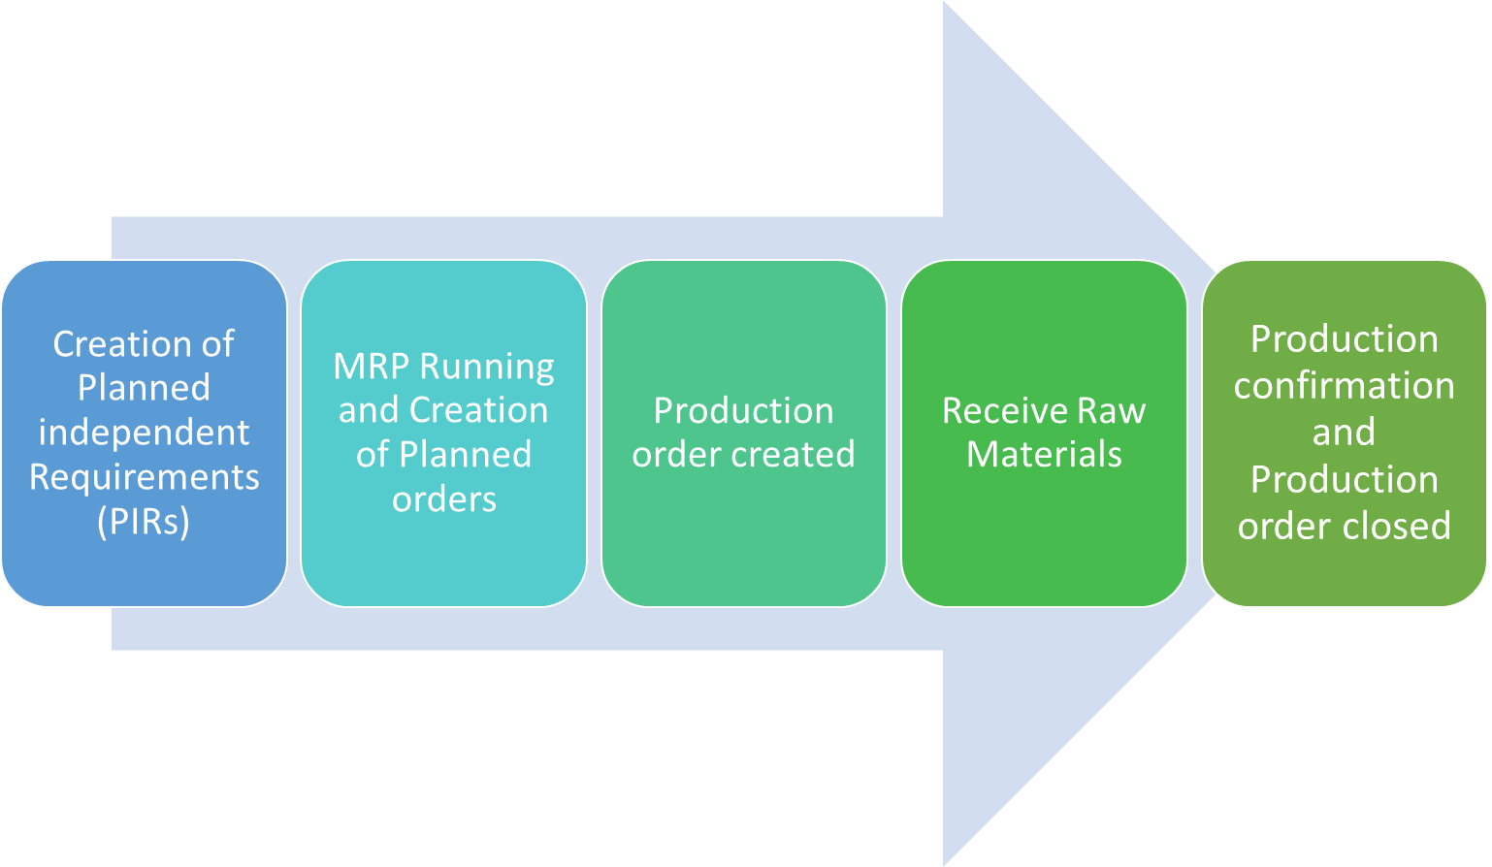

Alongside the desired scheduling date, the basis of detailed scheduling for an order, for example, are the capacity requirements of the activities. Optimum control which constraints, rules, and parameters the system must take into account during scheduling considering parameters like-

* Priority
* Capacity of Production Line
* Sequence of the Production orders
* Alerts

Digital Scheduler functionality in SAP will help scheduler to visualize the demand and capacity to derive optimum production like utilization and thus improve operational Excellence

**Digital Shop floor Execution**

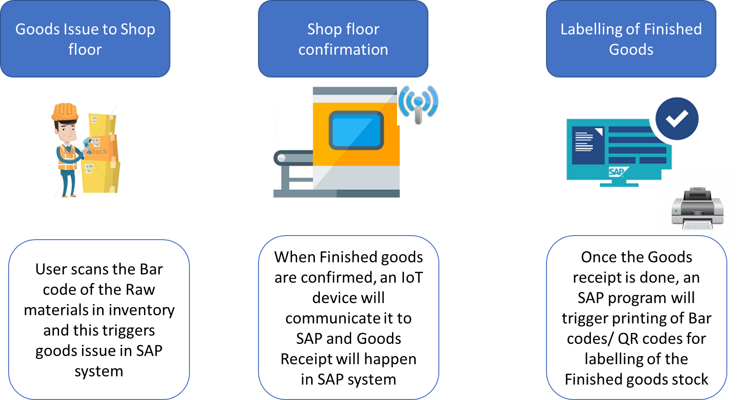

Digitization of the shop floor can be thus done in many other scenarios such as the above.

This will reduce human error, improve shop floor productivity and efficiency and provide real time data to management.

**Benefits of Digital Shop floor**

* Reduces human error
* Increases efficiency of shop floor
* Improves shop floor productivity
* Better accuracy and precision
* Provides real time data to management

**Industry coverage**

DigiZura has the capability to implement digital shop floor in various industries mentioned below

* Manufacturing
* Automobile
* Wires and Cables
* Steel and Metal processing
* Consumer goods
* Cement